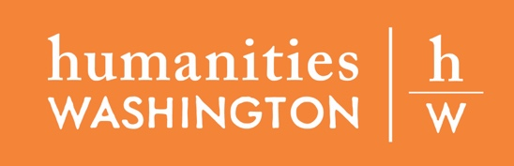

FOR IMMEDIATE RELEASE: [Date]
CONTACT:
[Host contact person]
[Host organization]
[Host address]
[Host email | phone number]

PUBLIC HUMANITIES TALK, [TALK TITLE], ON [DATE]
[HOST NAME] AND HUMANITIES WASHINGTON PARTNER TO PRESENT [SPEAKER DESCRIPTOR – i.e., HISTORIAN, STORYTELLER, PROFESSOR – SPEAKER NAME].

[HOST CITY] — [Host organization] and Humanities Washington invite the community to an engaging [in-person OR virtual] conversation with [speaker name], a member of the 2021-2023 Humanities Washington Speakers Bureau program, on [day, date, month, year].
About [Talk Title]
[Talk description – available at https://www.humanities.org/programs/current-speakers/]
About [Speaker Name]
[Speaker bio – available at https://www.humanities.org/programs/current-speakers/]
At a Glance
Who: [Speaker descriptor and name]
What: [Talk title]
When: [Day, date, month, year]
Where: [Venue address OR online registration link]
Questions?
Please contact [Name, title | email | phone number]
About Humanities Washington
Humanities Washington is a nonprofit organization dedicated to opening minds and bridging divides by creating spaces to explore different perspectives. For more about Humanities Washington, visit www.humanities.org.
About the Speakers Bureau Program
In communities throughout Washington State, Speakers Bureau presenters give free public presentations on history, politics, music, philosophy, spiritual traditions, and everything in between.
Their roster of over 30 Speakers Bureau presenters is made up of professors, artists, activists, historians, performers, journalists, and others—all chosen not only for their expertise, but also for their ability to inspire discussion with people of all ages and backgrounds. Hundreds of Speakers Bureau events take place each year. Find a Speakers Bureau event near you.
To reach as many Washingtonians as possible, Humanities Washington partners with a wide range of organizations, including libraries, schools, museums, historical societies, community centers, and civic organizations. Qualifying nonprofit organizations are encouraged to host a speaker.
The Speakers Bureau program is made possible with support from the National Endowment for the Humanities, the State of Washington via the Office of the Secretary of State, the Thomas S. Foley Institute for Public Policy and Public Service at Washington State University, and generous contributions from other businesses, foundations, and individuals.

About [Host Name]
[Mission statement]

